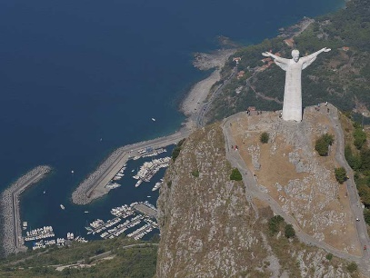

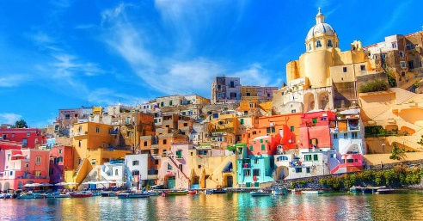

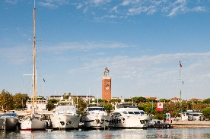

**TASTING TYPICAL TIELLA AND ANGEVIN-ARAGON'S CASTLE**

Gastronomic tour: guests will attend the preparation of typical baking dish of Gaeta, with subsequent tasting of the same.

The Gaeta Castle includes 14.100 m², is called Angevin-Aragon's castle because it consists of two adjoining buildings made in two different historical moments, one lower down said "Angevin", built during the French domination of Anjou, and one more at the top called "Aragon", built by Emperor Charles V along with all the other works of military defense who strengthened the fortress of Gaeta.

Details

Distance from Rome Airport: 110km

**Nautical Itinerary Gaeta-Maratea Gaeta: Days 1-3**

**GAETA**

The Base Nautica Flavio Gioia is a paradise corner in the middle of the Tyrrhenian Sea: all year temperate climate, halfway between the two most beautiful cities in south Italy (Rome and Naples) and a springboard to the most beautiful islands in the Tyrrhenian Sea. Waiting to decide where to direct the bow, you will find the best place to find comfort, immersed in a rich territory of art, history and traditions and fully seated in the vibrancy of city life and integrated with all services.

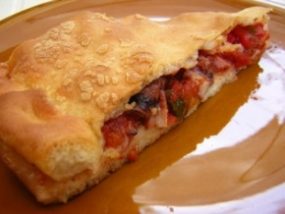

A tour through the islands and fascinating lands of the lower Tyrrhenian, to discover flavours and hidden treasures, in a combination of land and water that only Italy can tell so well.

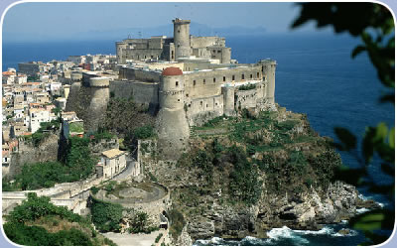

**GENERAL INFORMATION:**

**Total duration: 15 days**

**Miles: 378 NM**

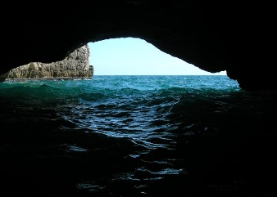

**THE DEVIL'S WELL VISIT AND THE 40 OARS' BEACH**

On board a characteristic 8 meters fishing boat, you'll visit the 40 oars' beach and the nearby Devil's Well, a large cave that develops both above the surface of the sea, with an entrance in which can penetrate a small boat, both under water. This site is interesting for divers: the depth is of few meters and the underwater life in the cave is of caveman type.



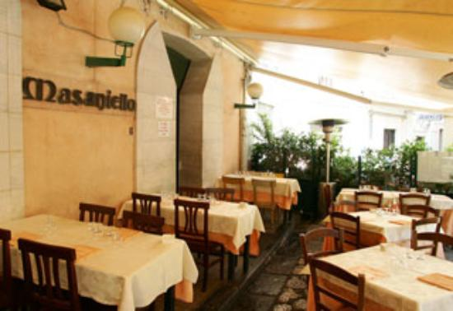

**DINNER AT RESTAURANT MASANIELLO - GAETA**

Winner of the prize for best fish soup of South Italy, Masaniello is one of the most popular restaurants of Gaeta.

It's located in Gaeta medieval district, in a very pretty square, where a statue of a lion dominates the centre.

In addition to the fish soup, you must taste the "votapiatto" squid (a sort of squid omelette a bit 'spicy), linguine with clams, seafood risotto, grilled mixed seafood.

**Nautical Itinerary Gaeta-Maratea Gaeta: Days 1-3 Ponza: Days 4-6**

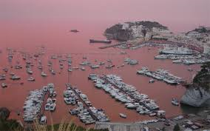

**PONZA'S MARINA**

Located in the largest of the Pontine Islands, it has a narrow and elongated shape and it extends from the La Guardia Stack, in the south, to Punta Incense, in the northeast.

Its beaches are jagged and mostly rocky, composed of kaolin and tuff, proving (along with numerous extinguished volcanic craters still recognizable) of the volcanic origin of the island. The presence of underwater caves and cliffs annually attract thousands of fans.

A tour through the islands and fascinating lands of the lower Tyrrhenian, to discover flavours and hidden treasures, in a combination of land and water that only Italy can tell so well.

Details:

Distance: 38NM from Gaeta

Transfer duration: 4h

Start: 9:00 AM

Arrival: ore 1 PM

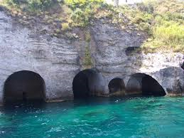

**COVES AND CAVES**

To make a selection in Ponza best attractions to see by sea is both easy than risky because of the danger of forgetting one of its lovely points.

Surely the Pilato's Cave and Happy's Cave, Hell's Cave and Capo Bianco leave an indelible memory in the visitor, but each point has a particular connotation and special, such as the Cat's Cave in the neighbouring Palmarola island.



**Nautical Itinerary Gaeta-Maratea Ponza: Days 4-5 Ventotene: Days 6-7**

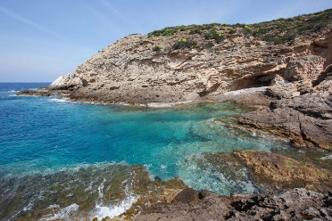

**THE ZANNONE ISLAND VISIT**

A day at sea following the obsidian's way as in prehistoric times, navigating around the island in the more beautiful sea of the Pontine Archipelago.

You'll visit the beautiful land and the intact nature of the Zannone's island, protected by the Circeo National Park since 1979: trees, lavenders, unique animals, the big mouflons and the Roman, medieval and modern historical remains.

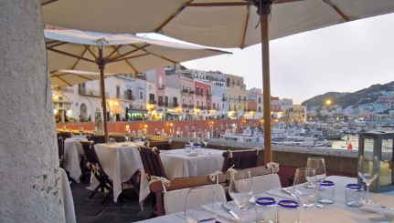

A tour through the islands and fascinating lands of the lower Tyrrhenian, to discover flavours and hidden treasures, in a combination of land and water that only Italy can tell so well.

**ACQUA PAZZA RESTAURANT - PONZA**

Along the beautiful proscenium of the port, an amphitheatre on the sea, while the kitchen celebrates the products: from crudité to eponymous "Acqua Pazza", the Acqua Pazza restaurant has earned over the years customers' and criticism's appreciation, until reaching the Michelin star that sets it apart.

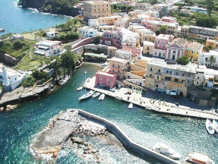

Details:

Distance: 25NM from Ponza

Transfer duration: 3h

Start: 9AM

Arrival: 12AM

**VENTOTENE**

Ventotene is at the half of the route that connects Ponza to Ischia and is the smallest inhabited island of the Pontine. Quiet, surrounded by a crystal clear sea, it offers the visitor a holiday in close contact with nature and its unique morphologies, scents of the Mediterranean, the intense colours combined with the warm hospitality of its inhabitants.

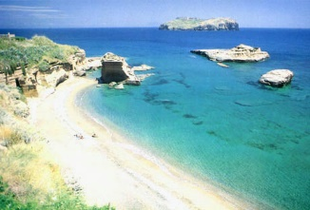

**COVES AND BEACHES**

The touristic-landscape heritage includes Cala Rossano (clear sandy beach included in the Marine Park's protection), the Postina's Parade (protected by a long plate of half-submerged tufa rock which nature has given the peculiar form of two arcs , such as to form a cave where you can hear the sound of the sea), the Big Parade in the northwest of the island (with a beach of sand grey colour that opens in a cove bordered by steep cliffs overlooking the sea), Battaglia Cove (fine black sand), Punta Pascone (beautiful black lava sand bottom).



**Nautical Itinerary Gaeta-Maratea Procida: Days 8-9-10**

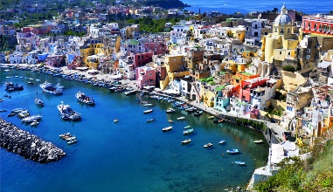

**PROCIDA**

Procida is situated at the entrance of the Naples' Gulf and is the smallest of the sisters islands Ischia and Capri. Procida is of volcanic origin, and you can still recognize in its typical half-moon bays, traces of ancient craters. The lively villages with multi-coloured houses, the rich vegetation within which merges a typical spontaneous Mediterranean architecture, the clear and shining sea, and beautiful coastal rocks generate landscapes of rare beauty views.

Details

Distance: 30NM from Ventotene

Transfer duration: 3h

Start: 9AM

Arrival: 12AM

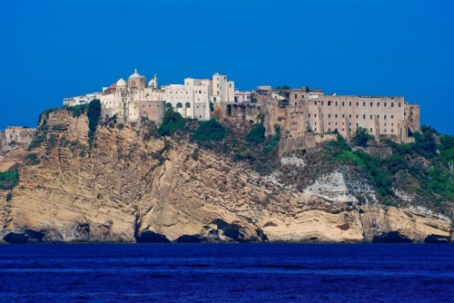

**CRENELLATED PALACE AND D'AVALOS PALACE**

Just arrived in Procida, you are in front of the Montefusco Palace of the twelfth century, called the "Chain" because at one time the rear driveway leading to the house was blocked to passers-by a chain, or even "Crenellated" for stupendous battlements overlooking the whole building.

The dominant building of Terra Murata is the d'Avalos Palace, built in '500 together with the walls by the family D'Avalos, the island's governors until the' 700. In 1830 the building was converted into a prison and was finally closed in 1988.

A tour through the islands and fascinating lands of the lower Tyrrhenian, to discover flavours and hidden treasures, in a combination of land and water that only Italy can tell so well.

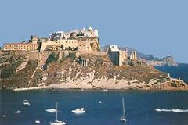

**SAINT MICHAEL ABBEY, CATACOMBS AND THE STRENGTHENED CENTER OF TERRA MURATA**

The Saint Michal Archangel Abbey is located on the promontory of Terra Murata, overlooking the sea about 91m above sea level. The imposing abbey testifies to the role he had in the past as a religious and cultural center of the island. Not to be missed is the tour of the underground where there is an ancient burial site. You must visit also the fortified center of Terra Murata, a place of great beauty built on the highest point of the island. Historical and cultural center of the island, Terra Murata can be reached only through bristly track from which you can admire a breathtaking view over the Naples' Gulf.



**Nautical Itinerary Gaeta-Maratea Procida: Days 8-9-10**

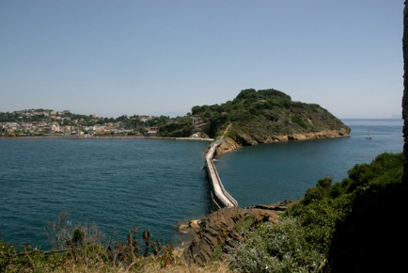

**BEACHES AND VIVARA ISLET**

Among the most beautiful beaches on the island, you can access the Chiaia beach from the street of well 182 steps. Shallow Water, dark sand, it's the most sheltered beach because it closed in the beautiful bay. The Old Well beach has a very grainy sand and you can take long swims, being locked up in its own bay. The Anthrax rocks are steep and difficult to reach, better get there by sea. The beauty of the place is unique and the seabed is among the deepest of the island. Cannot miss, finally, the visit to the Vivara island, a naturalistic oasis protected since 1974 and national nature reserve. Small, wild and unspoilt, this beautiful crescent lying on the sea, as well as being populated by rare species, wild rabbits and a variety of water birds and migratory that can also bewitch those less susceptible to the charms of nature. It's also a site of important archaeological finds of origin Mycenaean. Its sea, spectacular and rich in marine plants, are also an attraction for all diving enthusiasts.

A tour through the islands and fascinating lands of the lower Tyrrhenian, to discover flavours and hidden treasures, in a combination of land and water that only Italy can tell so well.

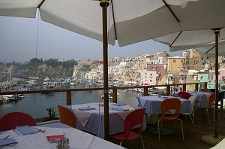

**LA LAMPARA RESTAURANT**

In a restaurant located in the most scenic of the fishing village of Marina Corricella, you can enjoy dishes from the ancient taste in contact with the sea. The fish is always fresh and fished with the Paranza, the family fishing boat. Among the sea breeze, the sun, the sound of fishing vessels and small boats, you can enjoy unforgettable flavors and always different, the result of what sea has donated in that day

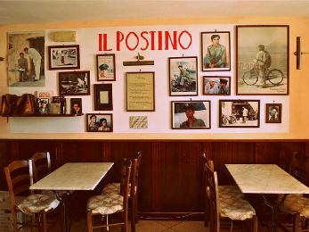

**LA LOCANDA DEL POSTINO RESTAURANT**

Here, in 1994, Massimo Troisi filmed "Il Postino": in the restaurant, in fact, there are still kept the bike and many other relics of the movie. Here you can taste seafood dishes using the freshest fish of the village and the typical dessert of Procida tradition, of course, made with lemon.



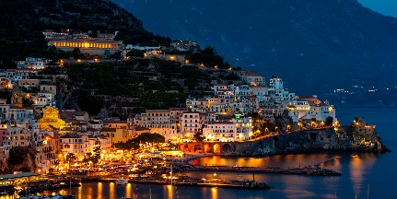

**AMALFI**

Amalfi is located along the valley of Canneto river, between Aureo Mount on the East and Tabor Mount on the west.

The center of the city is shaped like an inverted fan that measures approximately 1.5 kilometers in its widest point on the beach, and few hundred meters in the opposite side, in the Well Valley (about 2 km inland). This Valley is the urban part of the wider Ironworks Valley, the ancient "industrial area" of Amalfi, where there were the mills and the old ironworks, from which the name to the entire district. Due to its wildlife and environmental peculiarities,the Valley is now a natural reserve.

**Nautical Itinerary Gaeta-Maratea Amalfi: Days11-12-13**

Details

Distance: 38NM from Procida

Transfer duration: 4h

Start: 9:00 AM

Arrival: 1 PM

A tour through the islands and fascinating lands of the lower Tyrrhenian, to discover flavours and hidden treasures, in a combination of land and water that only Italy can tell so well.

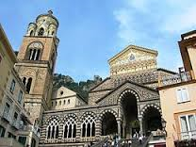

**SAINT ANDREW APOSTLE'S CATHEDRAL - PARADISE CLOISTER**

A real monumental complex, consisting of several autonomous bodies, intimately linked. The oldest part of the building is the Basilica of SS. Crucified, next to which it stands the present cathedral, which create one majestic Cathedral with six naves. Added to this there are the Bell Tower, the Crypt, designed to house the remains of St. Andrew the Apostle, and the Cloister of Paradise, in perfect Amalfi-Roman style, designed to be the Amalfi's Nobles' cemetery. Striking the structure of intertwined arcs going to unload on 120 marble columns, and above all the plays of color of porch created by the sun's rays peeking out from arabesque arches.

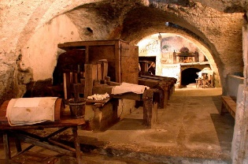

**PAPER'S MUSEUM**

The Foundation "Paper Museum" has always worked to spread, disseminate and document that concerns the art of making handmade paper of Amalfi. All this is possible thanks to the work of its founder, Nicola Milan.





**TREKKING PATH IN THE MILLS' VALLEY**

Starting from the center of Amalfi, you will head to the Ironwors' Valley, best known abroad as the "Valley of the Mills", passing through the small medieval village of the oldest town of the Amalfi Coast: Scala. Along the way you can enjoy the view of Amalfi from a unique point of view, walking through the lemon groves, typical cultivation of these places and the strict nature reserve, with its waterfalls and its rare plants.

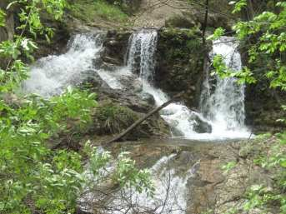

**Nautical Itinerary Gaeta-Maratea Amalfi: Days 11-12-13**

**LEMON TOUR**

The Aceto family works in the field of lemon cultivation and its transformation for six generations, precisely since 1825, when Salvatore Aceto bought a small piece of land in Ravello, beginning as a producer and trader. The tour, which starts from lemon field, will immerse you in the history of this family, through the words of those who are in love with this land and of this product, which you will taste directly from the plant. Following a slice of cake produced for you and a glass of lemonade will restore you before the visit to the rural museum and the limoncello factory.

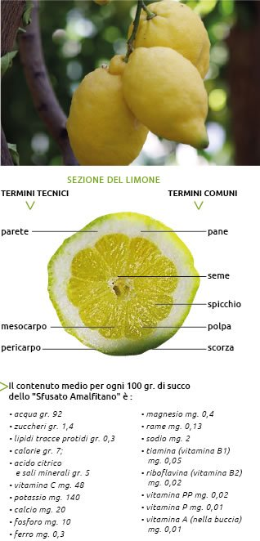

A tour through the islands and fascinating lands of the lower Tyrrhenian, to discover flavours and hidden treasures, in a combination of land and water that only Italy can tell so well.

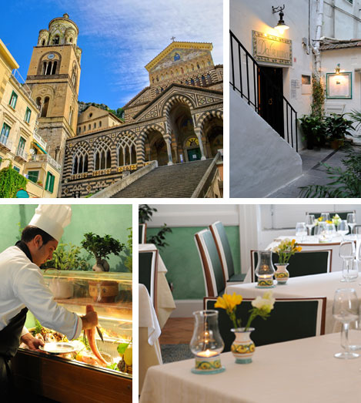

**GEMMA RESTAURANT**

We are in Amalfi, "water and land" paradise, between the sea and hills. Among its streets you can find the old restaurant Da Gemma: a continuing story, which is lasting nearly a century and a half remaining faithful to its seafood and Campania's recipes.

But it would be a mistake to imagine the kitchen stops to the Artusi's recipes. In fact, starting from tradition, the restaurant Da Gemma was able to innovate the variety, "reinventing" and elaborating those historical dishes, with the art and the peculiar style that characterizes it.



**Nautical Itinerary Gaeta-Maratea Amalfi: Days 11-12-13 Maratea: Days 14-15**

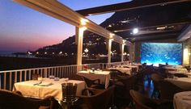

**MARINA GRANDE RESTAURANT**

The "Marina Grande" restaurant was born in 1918 as a bathhouse in the port area, overlooking the stretch of water that embraces the old town of Amalfi.

The waves break just off the covered terrace where you can enjoy seafood delicacies of all kinds, with the idea that a good meal is not only food and wine ...

but it is a journey that takes you to the rediscovery of the pleasures that you had forgotten, but also in places where you never were before.

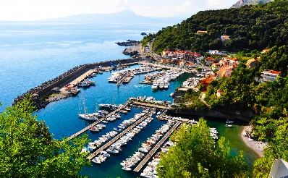

**MARATEA**

Unspoiled nature and excellent services, modernity and love for tradition make Maratea an ideal place to rest, offering beaches, sea and unique landscapes, the best facilities and the most complete services. 32 km of Tyrrhenian coast, with the mountains of Lucania, cultural and gastronomic treasures, the Mediterranean scrub.

A tour through the islands and fascinating lands of the lower Tyrrhenian, to discover flavours and hidden treasures, in a combination of land and water that only Italy can tell so well.

Details

Distance: 80NM from Amalfi

Transfer duration: 6h

Start: 9 AM

Arrival: ore 3 PM

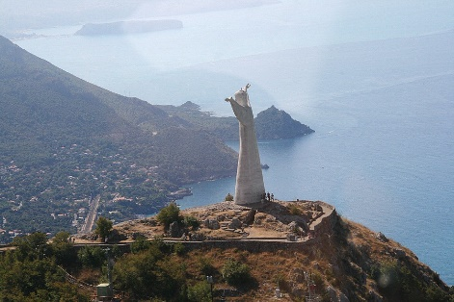

**CHRIST REDEEMER SCULPTURE AND SAN BIAGIO CHURCH**

Located in the ancient Maratea Superior, also called Castle, made by the sculptor Bruno Innocenzi, the statue was erected in 1965 on the summit of Monte San Biagio in the place where once stood a memorial cross in stone. Effectively it's located just opposite the Sanctuary of San Biagio, Armenian martyr, saint and Maratea's patron, whose relics are preserved in the Basilica. Along the uphill way that leads from Basilica to the Statue, you cross the ruins of the castle, destroyed by the French after the tender following a long siege.





**Nautical Itinerary Gaeta-Maratea Maratea: Days 14-15**

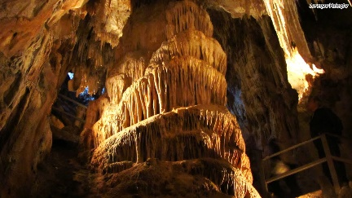

**CAVE OF WONDERS**

The Cave of Wonders, only touristic cave of Basilicata, opens in the municipality of Maratea, in Marina di Maratea fraction.

Its entrance is at 76 meters of altitude above sea level and was discovered in 1929 during work on the construction of the road n.18 of Calabria; precisely because the entrance is positioned to the side of this road, is extremely easy to reach by car, with easy parking.

A tour through the islands and fascinating lands of the lower Tyrrhenian, to discover flavours and hidden treasures, in a combination of land and water that only Italy can tell so well.

**NEPTUNE'S INN RESTAURANT**

The restaurant delights both the palate and the eyes, with a beautiful terrace with sea view, open on the Tyrrhenian Sea blue. For a romantic dinner by candlelight or a tasting of typical Mediterranean cuisine with friends, the restaurant will surprise you for the intimacy and warmth of the location. You can choose between different proposals based meat and fish, among which the dishes of seafood, local specialties. Vegetables and local products also have strictly local, as the excellent olive oil, produced directly from the family.

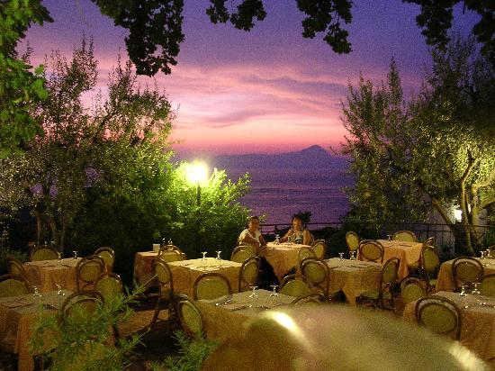

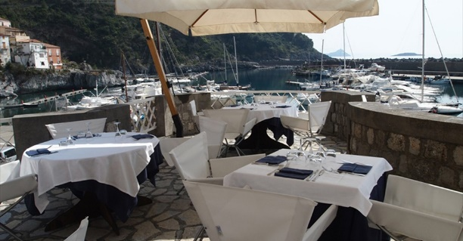

**1999 RESTAURANT**

In the splendid setting of the Port of Maratea, between the perfumes and the colours of the sea, it stands the 1999 restaurant: in a relaxing atmosphere and a lovely view, it will wrap your moments. 1999 restaurant is a stone's throw from the sea and serves tasty specialties based on fresh fish. It has a dining room and a round pool to enjoy the beautiful view of the Maratea Harbour.

Dettagli

Partenza: 16.30

Viaggio: 24 km verso Otranto

Arrivo: 17:00

Durta: 2h 30m